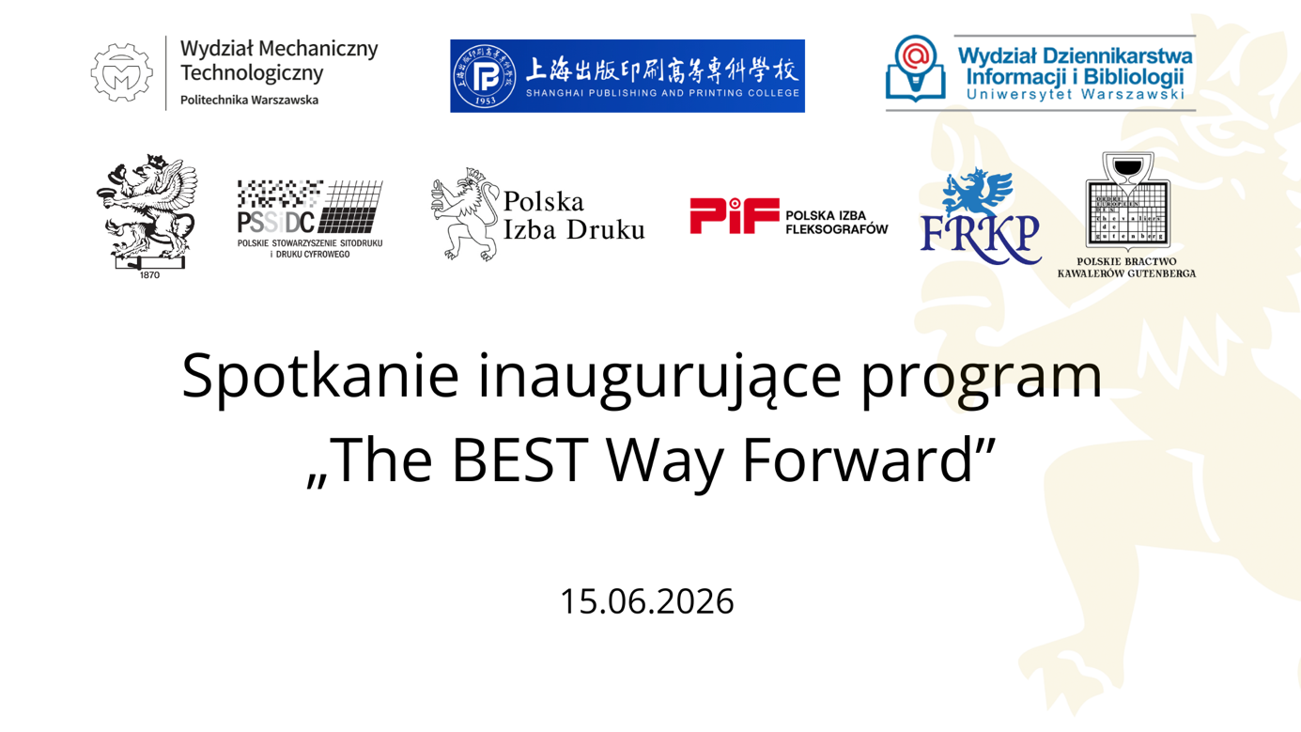
International launch of ‘The BEST Way Forward’ programme at the Warsaw University of Technology.

We are bringing together the worlds of business, education, science and technology to shape the future of modern vocational education.

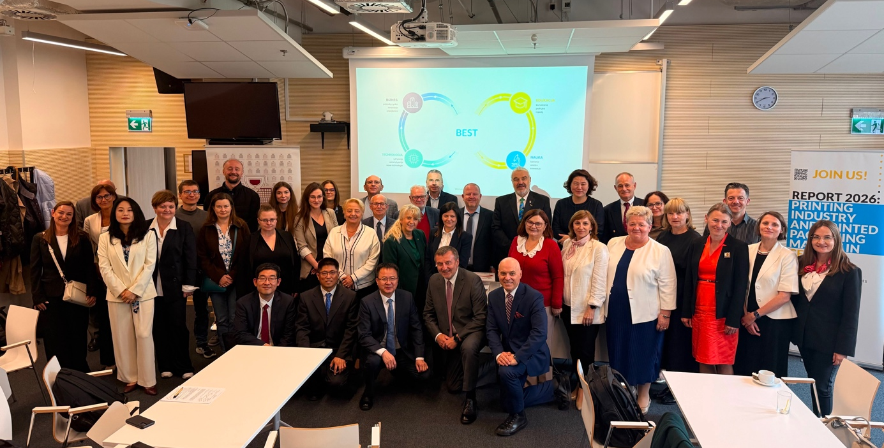

On 15 June 2026, the Warsaw University of Technology hosted the official launch of the international programme “The BEST Way Forward” (Business, Education, Science and Technology). The initiative was launched by the Faculty of Mechanical Engineering at the Warsaw University of Technology and the Polish Chamber of Printing.

The main aim of the event was to develop new forms of cooperation between the academic community, vocational education, industry organisations and businesses, with a particular focus on international educational partnerships.

The meeting was preceded by closed-door discussions on the potential for developing international cooperation between Shanghai Publishing and Printing College (SPPC) – a higher education institution specialising in training for the printing and packaging industries – and the management of the Faculty of Mechanical and Technological Engineering at the Warsaw University of Technology. Later in the meeting, Shanghai Publishing and Printing College outlined the college’s activities, presented the model of industry-education collaboration used in China, and discussed opportunities for developing research, teaching and student partnerships with Polish and European institutions.

The event was attended by nearly 60 representatives of public institutions, industry organisations and businesses, universities and vocational colleges, as well as international partners from China, Germany, Romania, Slovakia and Ukraine, confirming the growing importance of international cooperation for the development of modern education and the printing industry in Central Europe.

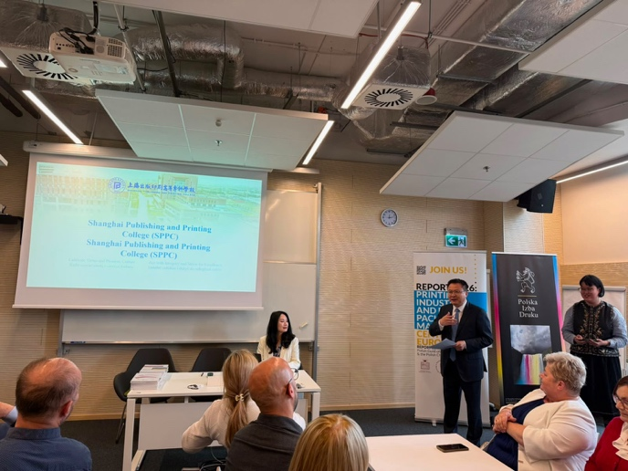
The programme included presentations highlighting the research and teaching potential of the university and industry organisations. Speakers included: Prof. Tomasz Chmielewski – Dean of the Faculty of Mechanical Engineering at the Warsaw University of Technology, Prof. Zuzanna Żołek-Tryznowska – Vice-Dean of the Faculty of Mechanical Engineering at the Warsaw University of Technology, Prof. Dariusz Kuźmina – Dean of the Faculty of Journalism, Information and Library Science at the University of Warsaw, Prof. Volker Jansen – Dean of the Hochschule der Medien Stuttgart, Prof. Li Jianhua – Rector of the Shanghai Publishing and Printing College, Prof. Jaroslav Uhryn – Vice-Rector of Lviv Polytechnic National University, Ištvan David – President of the Transylvanian Printers’ Association (Romania), Zoltan Kanovits – FESPA Slovakia, Magdalena Polak-Opałka and Katarzyna Sitko – Home Army Printing and Mechanical School Complex in Katowice.

Discussions centred on modern models of education, collaboration between industry and the education sector, the development of future-oriented skills, and opportunities for carrying out joint international research and educational projects.
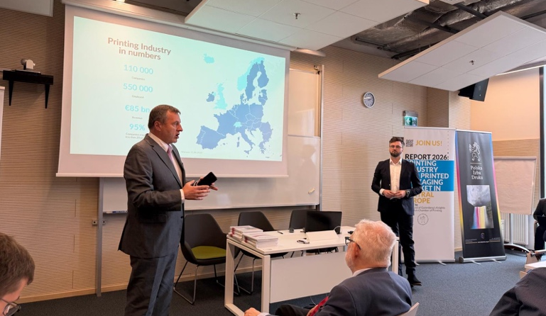
Another key element was the presentation by Aleksander Kuśmierczyk of the Polish Chamber of Printing on the ‘The BEST Way Forward’ initiative, which includes, amongst other things, the Next Generation Academy, the Bi Sheng Gutenberg workshops, industry reports and projects supporting the development of vocational education.

We would like to extend our warmest thanks to all participants for the inspiring discussions:

Representatives from Poland:
Warsaw University of Technology:
• Prof. Tomasz Chmielewski – Dean of the Faculty of Mechanical Engineering and Technology
• Dr Zuzanna Żołek-Tryznowska, Professor – Vice-Dean of the Faculty of Mechanical Engineering and Technology
• Anna Błaszczuk – Representative for Strategic Partnerships at the Faculty of Mechanical Engineering and Technology
Polish Chamber of Printing
• Jacek Kuśmierczyk – President of the Polish Chamber of Printing
• Maciej Sierpiński – Vice-President of the Polish Chamber of Printing
• Tomasz Mospan – Director of the Polish Chamber of Printing
• Artur Nowaczyk – Member of the Council of the Polish Chamber of Printing
• Aleksander Kuśmierczyk – Chief Analyst of the Polish Chamber of Printing
• Anna Hao – Secretary-General for Relations with China
• Alicja Jarząbek – Executive Assistant to the Management Board of the Polish Chamber of Printing

University of Warsaw
• Prof. Dariusz Kuźmina – Dean of the Faculty of Journalism, Information and Bookstudies

To representatives from Europe and China:
China (Shanghai Publishing and Printing College):
• Prof. Li Jianhua – Vice-Chancellor of Shanghai Publishing and Printing College, Vice-President of the University of Shanghai for Science and Technology
• Wang Dan – Director of the International Cooperation Office at Shanghai Publishing and Printing College
• Qiao Junwei – Head of the Department of Printing and Packaging Engineering at Shanghai Publishing and Printing College
• Yang Shengwei – Deputy Director of the Academic Affairs Office at Shanghai Publishing and Printing College.
Germany (Hochschule der Medien Stuttgart):
- prof. Volker Jansen – Dean of the Stuttgart Media University
Romania:
- Ištvan David – Asociatia Tipografilor Transilvania
Slovakia:
- Zoltan Kanovits – FESPA Slovakia / CEO Kanovits Print Atelier
Ukraine (Lviv Polytechnic University):
• Prof. Jaroslav Uhryn – former Vice-Chancellor of Lviv Polytechnic,
• Lesia Stetsiv – Dean of the Faculty of Printing,
• Orest Khamula – Coordinator of International Relations at the Ukrainian Academy of Printing
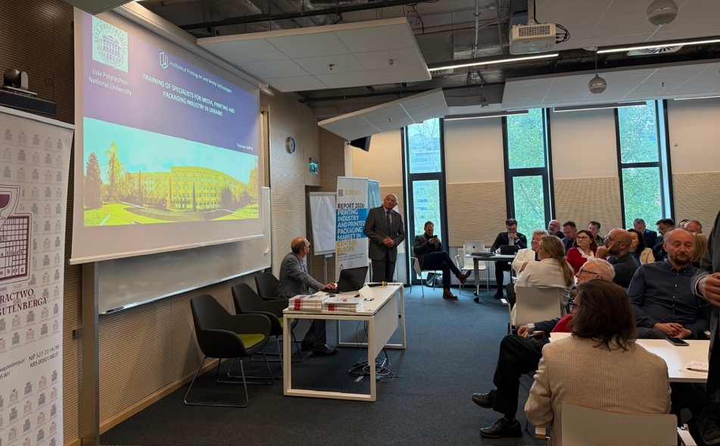

To the large gathering of representatives from secondary schools and printing technical colleges:
- Zespół Szkół Zawodowych Nr 6 im. Joachima Lelewela w Poznaniu
- Zespół Szkół Nr 26 w Warszawie
- Zespół Szkół Nr 4 w Skierniewicach
- Zespół Szkół Poligraficzno-Mechanicznych im. Armii Krajowej w Katowicach
- Zespół Szkół Poligraficzno-Medialnych im. Zenona Klemensiewicza w Krakowie
- Zespół Szkół nr 31 im. Jana Kilińskiego w Warszawie
- Zespół Szkół nr 1 im. Bohaterów Westerplatte w Garwolinie
- Zespół Szkół nr 3 w Łukowie
- Zespół Szkół Stenotypii i Języków Obcych w Warszawie (Technikum nr 29)
- Zespół Szkół nr 4 im. Eugeniusza Kwiatkowskiego w Warszawie
- Zespół Szkół Poligraficznych w Warszawie
- Zespół Szkół im. Piotra Wysockiego w Warszawie
- Technikum Księgarskie im. Stefana Żeromskiego w Warszawie
- Technikum Ekonomiczne nr 8 im. prof. Witolda Kieżuna w Warszawie

The “The BEST Way Forward” meeting confirmed that close cooperation between the academic, educational and business communities is crucial for effectively preparing future professionals for the challenges of the modern economy. Participants emphasised the high academic value of the event and the need to further develop international partnerships. The numerous discussions and contacts made pave the way for further joint educational, research and industry initiatives. The organisers hope that the meeting will mark the beginning of regular cooperation and a series of international events bringing together representatives from business, education, science and technology as part of “The BEST Way Forward” programme.

